 | Cambridge Maths Stage 2  Name: ………………………………………………….  Class: …………… Date: ………………………
Homework Week 2- Unit 1: Numbers to 100
Task 1: Fill in the missing numbers on the number lines.
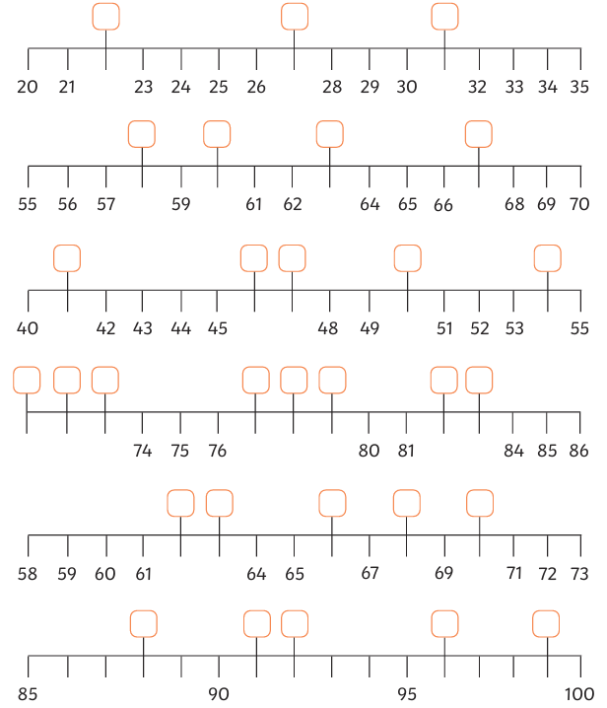
Task 2: Draw an arrow on the number lines to show your estimation of where that number places.

